Temasek Polytechnic
School of Informatics and IT

Diploma in Information Technology (IT)

Software Design Specifications (DS)

Project Particulars

Tutor | Ms Ho Li Chin
Class | P01
Project Title | Delonix Regia Hotel Management System

Project Team’s Particulars

Matric Number | Student Name
1400856I | Sim Zhi Yu
1400440B | Li Jin
14051865H | Kimberly Tan Jia Ying

Revision History

Date | Version | Description | Author
23/05/2016 | 1.1 | Draft | Kimberly Tan
25/05/2016 | 1.2 | Changes made to all sections | Kimberly, Lijin, Zhiyu
26/05/2016 | 1.3 | Updated Database design | Kimberly Tan

Table of Contents

1. DISTRIBUTION OF WORKLOAD 4
2. ARCHITECTURE DESIGN 4
3. USER INTERFACE (UI) DESIGN 6
4. PROGRAM DESIGN 11
5. DATABASE DESIGN 12

DISTRIBUTION OF WORKLOAD

Design | Members
Architecture Design | Sim Zhi Yu
User Interface Design | Li Jin
Program Design | Li Jin
Database Design | Kimberly Tan Jia Ying

ARCHITECTURE DESIGN

A three-tier architecture is a client-server architecture in which the functional process logic, data access, computer data storage and user interface are developed and maintained as independent modules on separate platforms. Three-tier architecture is a software design pattern and a well-established software architecture.
Three-tier architecture allows any one of the three tiers to be upgraded or replaced independently. The user interface is implemented on a desktop PC and uses a standard graphical user interface with different modules running on the application server. The relational database management system on the database server contains the computer data storage logic. The middle tiers are usually multitier.
Diagram of three-tier architecture
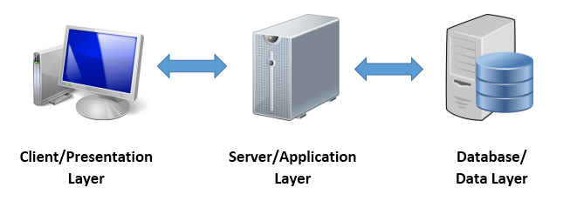
- Presentation Tier
Occupies the top level and displays information related to services available on a website. This tier communicates with other tiers by sending results to the browser and other tiers in the network.

- Application Tier
Also called the middle tier, logic tier, business logic or logic tier, this tier is pulled from the presentation tier. It controls application functionality by performing detailed processing.

- Data Tier
Houses database servers where information is stored and retrieved. Data in this tier is kept independent of application servers or business logic.

Benefits of three-tier architecture
- Scalability
If the organization owned more servers they can make use of data replication (for database servers) and load balancing for web application servers, thus being able to satisfy more incoming requests. All the clients require are a browser and a network connection.
The burden placed on the database server is lighter, as firms don’t need to have countless separate connections. This is because they make use of connection pooling – reusing existing connections among different client requests. It’s a known fact that creating and disposing of a connection has a significant impact on the overall response time for a database query.

- Maintainability
Developers need to focus only on the components of the application server. It’s not needed to test the application on several desktop configurations, thus saving long troubleshooting hours for errors occurring only for certain configurations.
Updates are available instantly to all clients, thus eliminating the trouble of managing deployment to client PCs.
Also, by having the logical tiers separated, code is more easily modifiable and replaceable than with the monolithic approach.

USER INTERFACE (UI) DESIGN

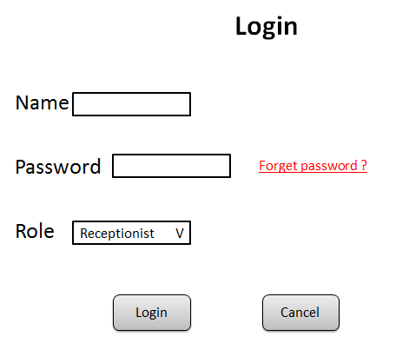

User can select their role to log into the system, so that the user can avoid entering wrong format and log into their own page properly.

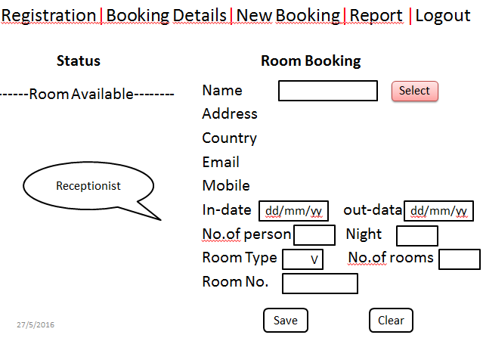

The room status and room booking are in one page, so that there will be more convenient for receptionist, administrator and manager to refer which room is available and book it for the guest.

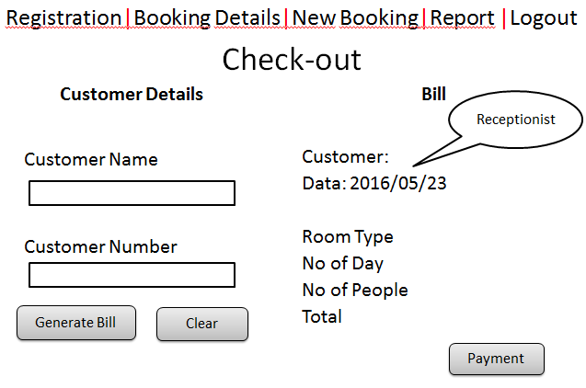

Customer detail and bill also be put in one screen, when the receptionist enter the customer name and no and click the generate bill, the bill side will be automatically shows the room type and total price for guest to make payment. This is more easily for receptionist to process.

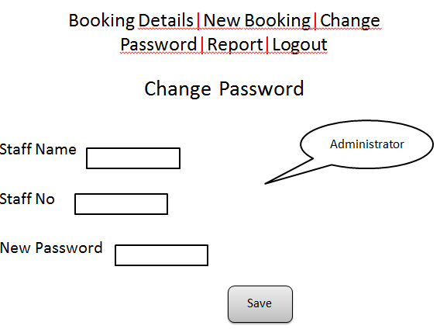

The administrator can use this page to create a new account for new staff, just enter the new staff name, staff no and new password, the new account will be created. And when the administrator changes the password for staff, they can just enter the staff name and no, and then change the new password, that’s will safe more time when doing this step. Administrator does not need to enter full information of a staff; it is because all the information has been saved to database when the staff came to the company at the first day.

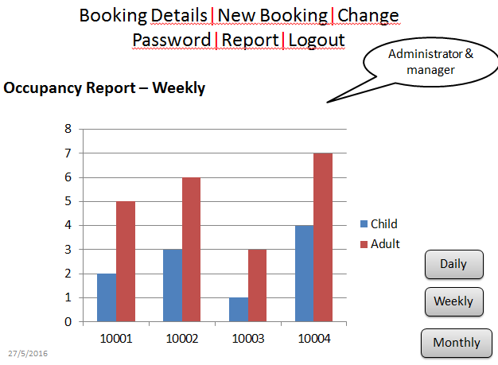

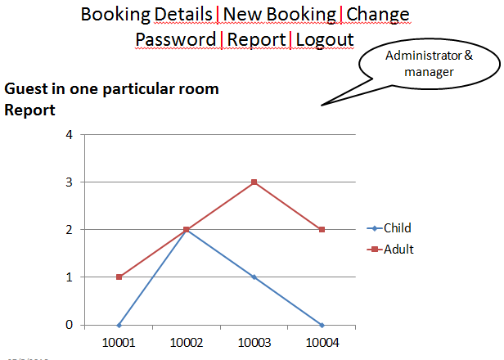

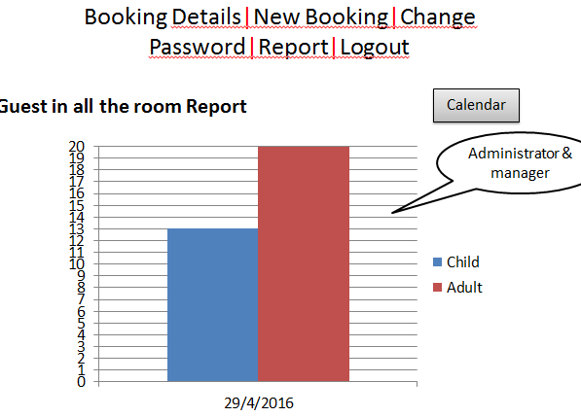

Using the chart to display the occupancy report, guest in one particular room report and guest in all room report will be more clearly. Child and adult are separated in different column that will easier for administrator and manager to compare the report by weekly and monthly. Furthermore, when the manager shows the report to Mr. Wang, he can easily to understand what the message of the diagram.

PROGRAM DESIGN

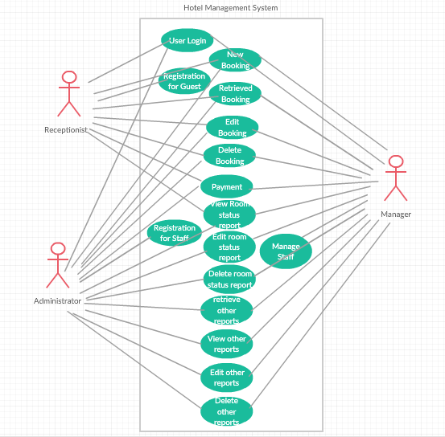

Basic Flow and Alternate Flow
Use case | User Login
Actor | Receptionist  Administrator  Manager
Description | Users enter the username and password, select their role to log into the hotel management system.
Basic Flow | Users enter the user name  Users enter the password  Users select the role  Users click “login” button when they want to use the system  Users can click the “cancel” button to skip login
Alternate Flow | If users enters wrong username and password  Users cannot log into the system  Users need to re-enter the username and password  If users select wrong role  Users cannot log into the system  Users need to re-select the role

Use case | Registration for Guest
Actor | Receptionist  Administrator  Manager
Description | Users register a account for walking in guest and store the data into database
Basic Flow | Users click “Registration” from function bar  Users enter the details of the guest  Users click “save” button to save the data

Use case | New Booking
Actor | Receptionist  Administrator  Manager
Description | When users log into system, they can book the room for the guest.
Basic Flow | Select the guest name  Enter the booking details  Click “save” button to save the information
Alternate Flow | If users select wrong guest name  Delete the wrong guest reservation from the booking details  Re-enter the correct guest name and booking information

Use case | Retrieve Booking
Actor | Receptionist  Administrator  Manager
Description | Users retrieve the booking information from the database
Basic Flow | Users click “Booking Details” from the function bar  All the booking information will be displayed in the table  Users can view the details of each reservation

Use case | Edit Booking
Actor | Receptionist  Administrator  Manager
Description | Users can update the reservation details when the guest change their check-out date or change rooms
Basic Flow | Click the “Booking Details” from the function bar  Click “Edit” for which one needs to be changed  Change the information  Click “update” button to update the information in the database

Use case | Delete Booking
Actor | Receptionist  Administrator  Manager
Description | Users can delete the booking when the guests cancel their booking.
Basic Flow | Click the “Booking Details” from the function bar  Click “Delete” to cancel the booking

Use case | Payment
Actor | Receptionist  Administrator  Manager
Description | Users make a payment for the guest check-out.
Basic Flow | Click the “Booking Details” from the function bar  Click “Check-out” to make the payment  Users need to enter the guest name and no  Users click “Generate bill” to turn to bill side  The bill information of the guest will be automatically showed in the bill side  Click “payment” to process

Use case | View Room Status Report
Actor | Receptionist  Administrator  Manager
Description | The room status report lists all the rooms in the hotel and the respective room status – vacant, occupied or vacant and schedule for cleaning
Basic Flow | Users click “report” from the function bar  Receptionist only can view the room status report  Administrator and manager can select the room status report from the report table

Use case | Edit Room Status Report
Actor | Administrator  Manager
Description | When the customer has been check-out, but the system cannot update the status of the room, administrator and manager can manually change the status of the report.
Basic Flow | Administrator and manager click “report” from the function bar  Administrator and manager can select the room status report from the report table  Click “Edit” to change the status of the report

Use case | Delete Room Status Report
Actor | Administrator  Manager
Description | Administrator and manager are able to delete the report when the report cannot provide the relevant information , and then retrieve a new room status report.
Basic Flow | Administrator and manager click “report” from the function bar  Administrator and manager can select the room status report from the report table  Click “Edit” to change the status of the report  Re-click “report” from the function bar  The new room status report will be posted again

Use case | Registration for Staff
Actor | Administrator
Description | Administrator create a new account for new staff to log into the system
Basic Flow | Administrator log into the system  Click the “change password” from the function bar  Enter the staff name and staff no  Enter the new password  Click “save” button to save the staff name and password

Use case | Manage Staff
Actor | Manager
Description | Manager assign the task to staff using the system
Basic Flow | Manager log into the system  Click the “manage staff” from the function bar  Click the staff name to view the staff information  Edit the staff duty  Delete the staff

DATABASE DESIGN

Considerations
- The purpose of the database and how it affects the design. Create a database plan to fit your purpose.
- Achieving a balance between the size of the database and the hardware configuration is also important for performance.
- Maintenance.
- Estimating the size of a database.
- We have 3 modules in the system, we have to ensure all the data required are included in the database.
- Only some staff are allowed to access a certain module.

Decisions
- We have three modules to be included in this system, therefore the database shall be a bigger database.
- We have to ensure that the system only allows staffs to login into certain modules.
- There many staffs in the hotel, we have to classified them to make it clearer in the database.

ER Diagram for all 3 module

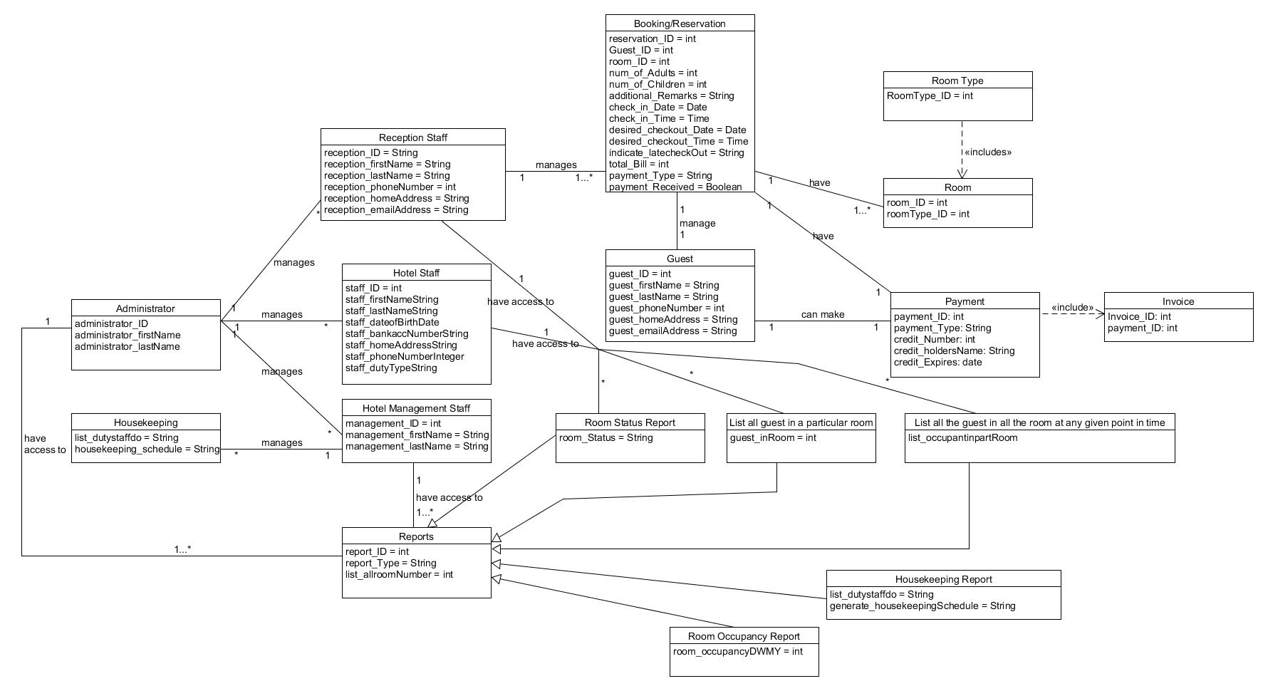
This ER diagram shows the relationship from one entity to another. For example, one reception staff can manage many reservations and one reservation can have many rooms.

Database Schema

- Room availability and booking module
The reservation entity contains the ID of all required entity, this would allow the reception staff to see all information for this particular reservation. The ID of other entity act as a foreign key in reservation entity.
Reservation {reservation_ID, Guest_ID, room_ID, num_of_Adults, num_of_Children, additional_Remarks, check_in_Date, check_in_Time, desired_checkout_Date, desired_checkout_Time, indicate_latecheckOut, total_Bill, payment_Type, payment_Received, reception_ID}

Guest {guest_ID. guest_firstName, guest_lastName, guest_phoneNumber, guest_homeAddress, guest_emailAddress}

Room {room_ID, roomType_ID}

Room Type {RoomType_ID}

Payment {payment_ID, payment_Type, Reservation_ID, credit_Number, credit_holdersName, credit_Expires}

Invoice {Invoice_ID, payment_ID}

Reception Staff {reception_ID, reception_firstName, reception_lastName, reception_phoneNumber, reception_homeAddress, reception_emailAddress}

- Housekeeping and staff management module
The housekeeping entity contains the ID of all required entity, this would allow the management staff to see all information for this particular housekeeping record. The ID of other entity act as a foreign key in housekeeping entity. The administrator does not have a foreign key.

Housekeeping {list_dutystaffdo, reception_ID, staff_ID, management_ID}

Reception Staff {reception_ID, reception_firstName, reception_lastName, reception_phoneNumber, reception_homeAddress, reception_emailAddress. staff_dutyType}

Hotel Staff {staff_ID, staff_firstName, staff_lastName, staff_dateofBirth, staff_bankaccNumber, staff_homeAddress, staff_phoneNumber, staff_dutyType}

Hotel Management Staff {management_ID, management_firstName. management_lastName, staff_dutyType}

Administrator {administrator_ID, administrator_firstName, administrator_lastName}

- Reporting module
All the reports contains a report ID which is also a foreign key.

Reports {report_ID, report_Type, list_allroomNumber}

Room Status Report {statusReport_ID, report_ID. room_Status}

List all guest in a particular room {guestInRoom_ID, report_ID. guest_inRoom}

List all the guest in all the room at any given point in time {guestInroomTime_ID, report_ID. list_occupantinpartRoom}

Housekeeping Report {Housekeeping_ID, report_ID. list_dutystaffdo, generate_housekeepingSchedule}

Room Occupancy Report {Occupancy_ID, report_ID. room_occupancyDWMY}

Database design

Reservation

 | Data Type
reservation_ID | Primary Key, Integer (20)
num_of_Adults | Integer (100)
num_of_Children | Integer (100)
additional_Remarks | Varchar (200)
check_in_Date | Date
check_in_Time | Time
desired_checkout_Date | Date
desired_checkout_Time | Time
indicate_latecheckOut | Date/Time
total_Bill | Decimals (10,2)
payment_Type | Foreign key, Char (20)
payment_Received | Varchar (20)
Guest_ID | Foreign key, Integer (20)
room_ID | Foreign key, Integer (20)
reception_ID | Foreign key, Integer (20)

Guest

 | Data Type
guest_ID | Primary Key, Integer (20)
guest_firstName | Varchar (100)
guest_lastName | Varchar (100)
guest_phoneNumber | Integer (20)
guest_homeAddress | Varchar (100)
guest_emailAddress | Varchar (100)

Room

 | Data Type
room_ID | Primary Key, Integer (20)
roomType_ID | Foreign Key, Integer (20)

Room Type

 | Data Type
roomType_ID | Primary Key, Integer (20)

Payment

 | Data Type
payment_ID | Primary Key, Integer (20)
payment_Type | Varchar (100)
Reservation_ID | Foreign Key, Integer (20)
credit_Number | Integer (100)
credit_holdersName | Varchar (100)
credit_Expires | Date

Invoice {Invoice_ID, payment_ID}

 | Data Type
Invoice_ID | Primary Key, Integer (20)
payment_ID | Foreign Key, Integer (20)

Reception Staff

 | Data Type
reception_ID | Primary Key, Integer (20)
reception_firstName | Varchar (100)
reception_lastName | Varchar (100)
reception_phoneNumber | Integer (20)
reception_homeAddress | Varchar (100)
reception_emailAddress | Varchar (100)

Housekeeping

 | Data Type
list_dutystaffdo | Varchar (100)
reception_ID | Foreign Key, Integer (20)
staff_ID | Foreign Key, Integer (20)
management_ID | Foreign Key, Integer (20)

Hotel Staff

 | Data Type
staff_ID | Primary Key, Integer (20)
staff_firstName | Varchar (100)
staff_lastName | Varchar (100)
staff_dateofBirth | Date
staff_bankaccNumber | Integer (100)
staff_homeAddress | Varchar (100)
staff_phoneNumber | Integer (20)
staff_dutyType | Varchar (100)

Hotel Management Staff

 | Data Type
management_ID | Primary Key, Integer (20)
management_firstName | Varchar (100)
management_lastName | Varchar (100)
staff_dutyType | Varchar (100)

Administrator

 | Data Type
administrator_ID | Primary Key, Integer (20)
administrator_firstName | Varchar (100)
administrator_lastName | Varchar (100)

Reports

 | Data Type
report_ID | Primary Key, Integer (20)
report_Type | Varchar (100)
list_allroomNumber | Integer (100)

Room Status Report

 | Data Type
statusReport_ID | Primary Key, Integer (20)
report_ID | Foreign Key, Integer (20)
room_Status | Varchar (100)

List all guest in a particular

 | Data Type
guestInRoom_ID | Primary Key, Integer (20)
report_ID | Foreign Key, Integer (20)
guest_inRoom | Varchar (100)

List all the guest in all the room at any given point in time

 | Data Type
guestInroomTime_ID | Primary Key, Integer (20)
report_ID | Foreign Key, Integer (20)
list_occupantinpartRoom | Varchar (100)

Housekeeping Report

 | Data Type
Housekeeping_ID | Primary Key, Integer (20)
report_ID | Foreign Key, Integer (20)
list_dutystaffdo
generate_housekeepingSchedule | Varchar (100)

Room Occupancy Report {Occupancy_ID, report_ID. room_occupancyDWMY}

 | Data Type
Occupancy_ID | Primary Key, Integer (20)
report_ID | Foreign Key, Integer (20)
room_occupancyDWMY | Varchar (100)

References
https://www.techopedia.com/definition/24649/three-tier-architecture
http://blog.beleringenierie.com/en/2011/05/05/english-3-tier-architecture-what-is-it-do-we-need-it/

